Why Do We Do What We Do?

Worship Service

Why do we worship?
Worship is our natural and free response as humans to our Creator. It is a response to the beauty, love, adoration, our deepest fears and sorrow, and our greatest joys. In worship, we unite and are brought together in common action. We worship because, as Alexander Schemamann describes, it is our initial act of thanksgiving, “of returning the world to God.” Since we are human, worship allows for us to draw nearer to God. Additionally, in worship, we pray and we learn through our prayer, which shapes our belief – as indicated in the Latin phrase, lex orandi, lex credenda.

Why do we come to Church?
We come to Church to participate in our corporate worship of the Almighty God. We gather to be enriched by the Word of the Lord and the teachings from Scripture, to share in the remembrance of the sacrifice, death, and resurrection of Jesus Christ, and to partake in the grace of the sacrament of Holy Communion. Importantly, the Church is not an end in itself. We come to Church to be transformed and sent out into the world to aid in the restoration of all people to unity with God, participate in the restoration of unity with each other in Christ, and, as the deacon declares in the dismissal, “Let us go forth into the world, rejoicing in the power of the Spirit.” In coming to Church, we make present God, the Creator and source of life, and the author of our salvation.

Why are there candles on the altar?
The candles are a symbol of the light of Christ. From John 8.12, we are reminded by the visible flame that Christ is the “light of the world” and from John 1.5, the “light shines in the darkness, and the darkness did not overcome it

Why are vestments worn?
Vestments are worn for the glory of God. Within the beauty of the liturgy, the vestments worn by clergy in one sense identify the clergy and their role within the service, signifying their special ministries. Yet, the dignified rich fabrics and designs turn our attention towards God, who by grace, works in and through us all and for whom they are offered in glory.

How is the Bible used in the service?
During the service, we hear readings from four passages in Scripture – three lessons (most frequently an Old Testament passage, a New Testament passage, and a passage from one of the four Gospels) and a psalm. Within the Anglican Church of Canada, the readings are arranged according to a lectionary – a three-year cycle of selected passages. Over the course of the three years of Sundays, nearly the entire New Testament and a significant portion of the Old Testament is read. Although the readings from Scripture constitute the majority of how the Bible is used in the service, passages and verses from the Bible are woven into the framework of our liturgy – within the prayers, hymns, and anthems. The Bible becomes not only a source of instruction as God’s Word to us, but it becomes a form of prayer. It is the language we use to respond to God, as well as a form of expression of our needs and God’s limitless glory.

What are the two parts of the service?
The service of Holy Eucharist each Sunday is a combination of two parts, the liturgy of the Word and the liturgy of the Sacrament, or Holy Communion. During the liturgy of the Word, we listen to readings from Scripture and learn about God and his work in the world. The liturgy of the Sacrament is the portion of the service where we offer our sacrifice of praise and thanksgiving and come to receive Communion.

Participation in Worship

Why are children encouraged to attend?
Children are not only welcome to attend, but are highly encouraged. Within the Anglican Church of Canada, children, including infants, can be baptized. In baptism, sponsors of the child vow to “be responsible for seeing that the child is brought up in the Christian faith and life” and to help the “child to grow into the full stature of Christ.” As baptized individuals, they are part of the Body of Christ. Part of learning and growing in the knowledge and love of God is through the receiving of the Sacrament of Holy Communion as well as learning in corporate worship from the reading of the Word of God. Even children not yet baptized are able to listen and learn in preparation of renouncing Satan and evil and turning to Jesus Christ as Lord and Savior in the Sacrament of Baptism.

Why do we kneel?
Kneeling is a posture of showing reverence and humility. In kneeling, we respond to God in thought, with or without words and in our action acknowledge the holiness of God. At St. Luke’s, we kneel as our posture of prayer and as our posture for offering our contrition of sins. Additionally, as kneeling is a posture of displaying honor before kings, we kneel to honor and show obedience to our Lord, our King, and Savior, Jesus Christ.

When do I stand, sit, and kneel?
Normally, we stand when we praise God and affirm our faith, sit to listen and learn from the reading of Scripture and during the sermon, and kneel to pray and confess our sins. Standing is a position of showing respect and expressing our thanksgiving and adoration. During the service, we stand at the beginning of the service, during hymns and songs of praise, for the reading of the Gospel, during the Creeds, during the exchanging of the peace, while the offerings are presented, the beginning of the Great Thanksgiving, and for the dismissal. Standing is also an appropriate position for praying; although, here at St. Luke’s, we kneel as a sign of reverence and humility when we pray. During the service, we kneel for the Prayers of the People, to confess our sins against God and our neighbor, for the Eucharistic Prayer, and for the Post Communion prayer. Sitting is a posture for learning and listening to God’s Word. During the service, we sit to listen to the readings from Scripture and for the sermon.

Why are there moments of silence?
Silence is a vital aspect of our worship. Silence is an opportunity to offer our own silent prayers or to reflect and meditate on what has been read and taught. Additionally, silence is an opportunity to be still and experience the joy of being in God’s presence; recalling 1 Kings 19.12, when Elijah meets the Lord not in the wind, earthquake, or fire, but in the “sound of sheer silence.”

Why is there an offering?
Everyone, regardless of age, has something to offer. We all are unique in our gifts and as such we use them to the benefit of His kingdom. As part of the service, we take up a collection, called the offering. The offerings are not fees or dues given out of obligation, but represent a sacrifice and are gifts of thanksgiving returned to God from the overflowing of gratitude found within our hearts. The Anglican Church of Canada recommends a starting point of donating 10% of one’s income, called the tithe. It is not a requirement, but the Church gratefully receive any contribution as it assists in the mission and life of the Church. We grow in faith by drawing nearer to Christ. Out of our gratitude for his sacrifice and generosity, our own generosity develops as we turn the focus away from ourselves and towards giving money to that which we are grateful for and to donating to those in need. Contributions to the Church are tax deductible, allow for the continued presence of St. Luke’s, and assist in the outreach and mission to the community and the world.

Communion

Why is there Communion so often?
In understanding why there is Communion do often, it is important to understand what Communion (or the Lord’s Supper or Holy Eucharist) is. Alexander Schmemann describes the Eucharist as “the entrance of the Church into the joy of its Lord.” Christ instituted Communion for the continual remembrance of His sacrifice, death, and resurrection. In partaking in Communion, we receive and are filled with grace and divine blessings from God, despite our own unworthiness. We partake in Communion regularly to remember and celebrate our redemption in Christ, offer our sacrifice of praise and thanksgiving, be united with Christ in his real presence as well as with each other, and share in the foretaste of the heavenly banquet. The celebration of the Holy Eucharist is central in that it is one of the two great signs of grace (Sacrament) in the Church; also evidenced by its placement in the middle of the Book of Common Prayer. As such, we enter into joy with our Lord each week with Communion.

What happens at Communion?
During Communion, the gifts of Bread and Wine become for us the sacraments of the Body of Christ and his Blood. The Body is broken, taken, given, and eaten in Communion, uniting us to Christ in his sacrifice, filling us with grace and divine blessings from God. In Communion, we remember Christ’s sacrifice, death, and resurrection, and we partake in the foretaste of the future heavenly banquet. During the service, ushers will indicate the moment appropriate to leave the pew and kneel (or stand if unable to kneel) at the altar railing to receive Communion.

Who may receive Communion?
In the Anglican Church of Canada, Communion is open to all baptized Christians regardless of denomination. Before partaking in communion, we examine ourselves, confessing our sins and repenting, and loving our neighbors as ourselves.

St. Luke’s is a congregation of the
Anglican Diocese of Fredericton and the worldwide Anglican Communion
The Right Reverend David Edwards | Bishop
The Reverend Canon David Barrett | Priest-in-Charge
The Reverend Cole Hartin | Deacon

For additional information on the Anglican Church of Canada,
our beliefs, and our work, please visit the following websites:

Website of St. Luke’s Anglican Church: http://www.stlukessj.com
Website for the Anglican Diocese of Fredericton: http://www.anglican.nb.ca
Website for the Anglican Church of Canada: http://www.anglican.ca
Website for the larger Anglican Communion: http://www.anglicancommunion.org/

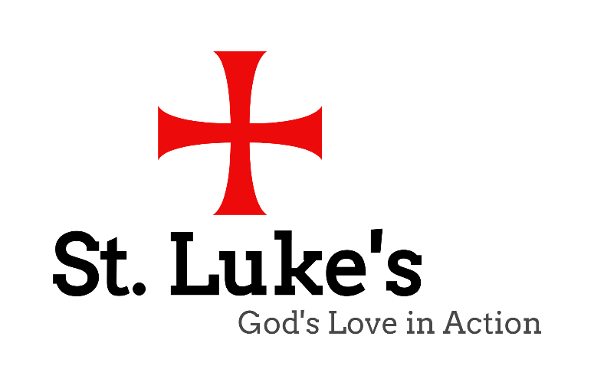

Po Box 22078 RPO Lansdowne
Phone: (506) 693-4152
Office Hours
Monday, Wednesday and Thursday: 9:00 a.m. to 5:00 p.m.
Tuesday: 9:00am to 3pm Friday: 9:00 a.m. to 12:00 p.m.
E-mail: stlukesportland@gmail.com Website: http://www.stlukessj.com
Facebook: https://www.facebook.com/groups/112879742067984/

